Part One: How to Create, Execute and Save C Programs
Using Microsoft Visual Studio 2012
Step 1: Start Visual Studio 2012
Start All Programs Microsoft Visual Studio 2012 Visual Studio 2012
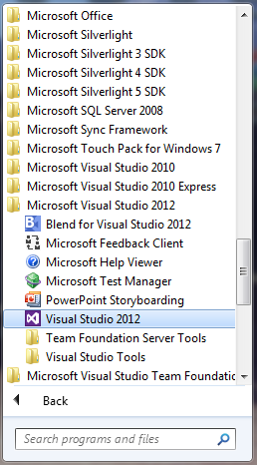
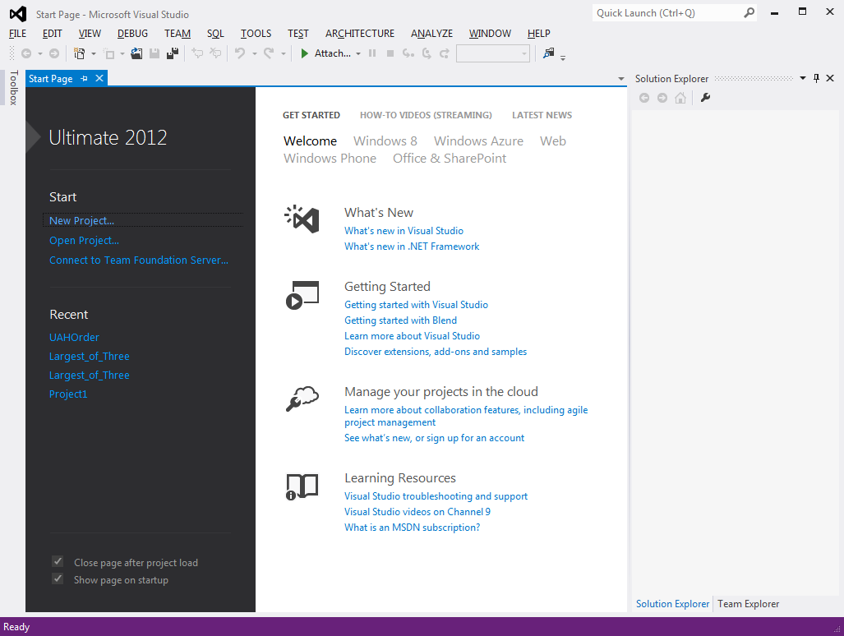
The window shown below will appear. (NOTE: If this is the very first time you are starting MVS 2012 then a preliminary window will appear first that will ask you to select a default environment. In that case click on the C++ environment and continue. Then the window at right will appear. )

Step 2: Prepare to create a new C Program Project
Step 2.1: File New Project
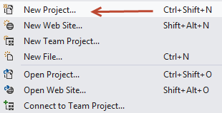
Another window will open as shown below.
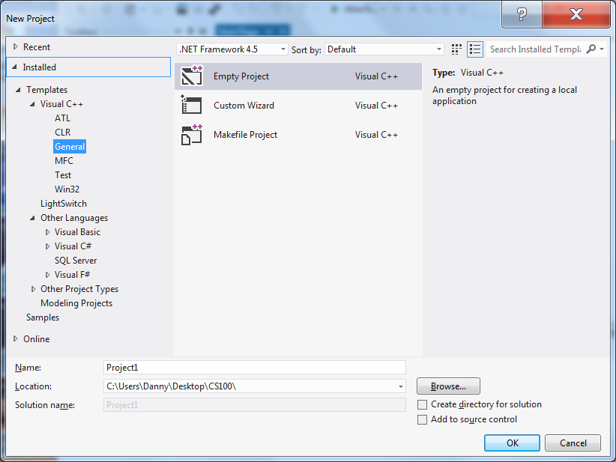
Dialog box for selecting the Programming language (C++), Naming the project and choosing the folder to save results.
Step 2.2: Select the programming language from the left side panel.
Visual C++ General (NOTE: if you do not see the C++ choice then click on the “Other Languages” tab to open.)
Step 2.3 Select “Empty Project” in the central panel.
Step 2.4 Type a name for your project in the “Name” text box at bottom. (NOTE: This is NOT the name of your C Program File. That will be set in another step below. An example project name could be “Homework One”)
Step 2.5 Click the Browse Button to specify the folder where all your work will be stored. In the classroom you will need to create a folder on the for this. Name it CS102.
Step 2.5 Make sure that the two check boxes at lower right are both UNCHECKED.
Here is an example:
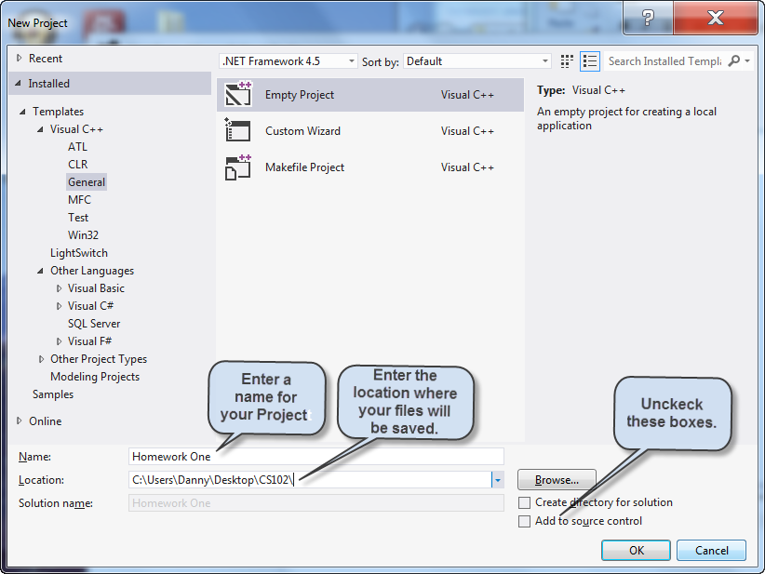
Screen capture of dialog box with all information for creating a new C Project.

Step 2.6 When all is set click “OK” The following window will appear. Note that your project name appears in the “Solution Explorer Panel”
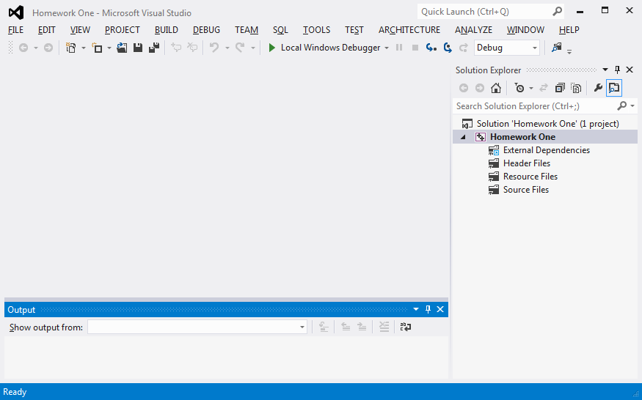
That completes all the preparations for a new Project. Now we need to configure MVS 2012 to add a C Program file.
Step 2.7 Add a new C Program “Item” to the Project
Project Add New Item
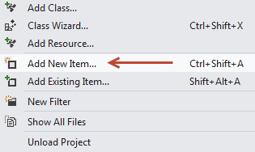
The following window will appear:
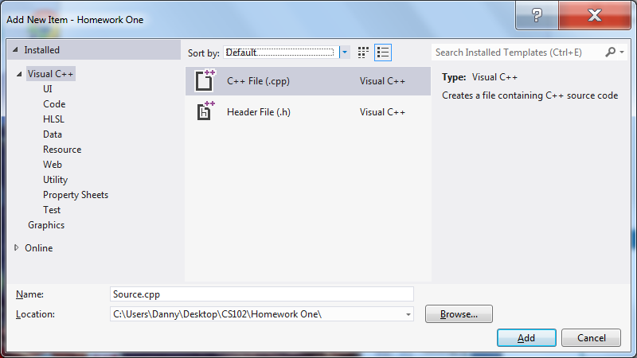
Dialog box for specifying a new C Program file.
Step 2.8 Select “Code” from the “Installed” panel on the left side.
Step 2.9 Select C++ File (.cpp) from central panel
Step 2.10 Enter the name for the C Program file in the “Name” text box. This file name cannot contail spaces and must begin with a letter. Underscores are OK.
IMPORTANT name the file with a .c extension not .cpp
For Example hello.c
Step 2.11 Make sure that the Location is still set to C Drive.
The completed dialog box is shown below.
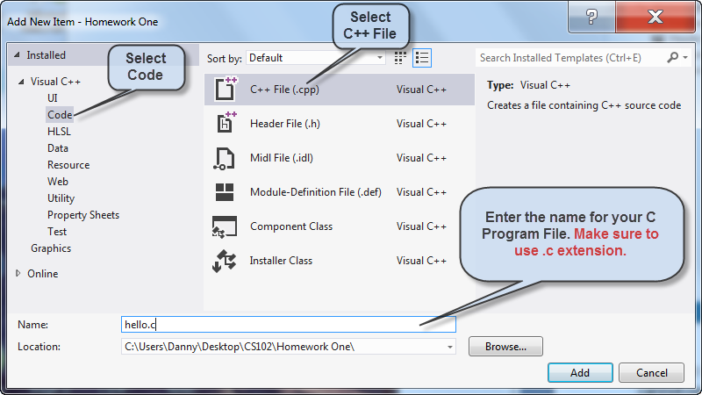
Dialog box with information for the C Source Code file
Step 2.12 Click the “Add Button
The main MVS 2012 Window will now have a tab with the name of your C code file. This is where you will type in your C program.
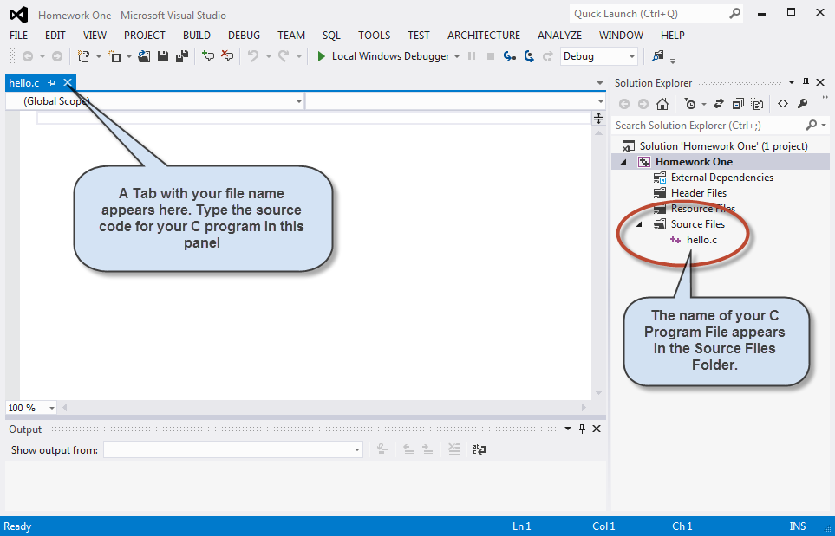
MVS 2012 window ready for entry of C Program source code.

Step 3 Write your C program.
Step 3.1 Type (Do not copy and paste. It will not work) the following simple program:
#include <stdio.h>
#include <stdlib.h>
int main(void)
{
printf(“Hello World\n”);
system(“pause”);
}

You should have the following (or similar) on your screen:
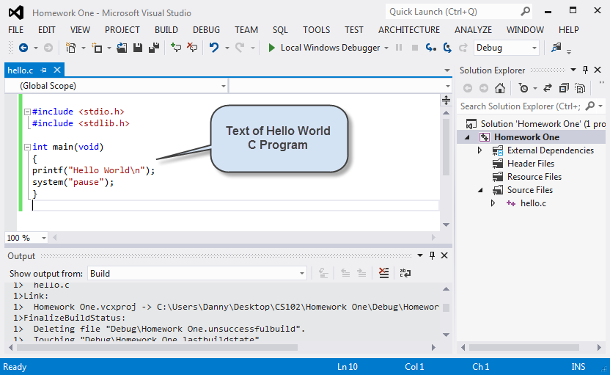
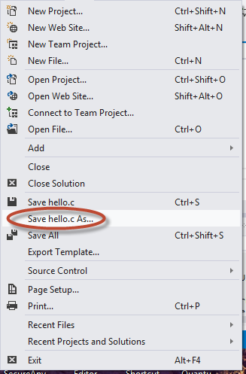
Screen view of MVS 2012 with simple C program source code.
Step 3.2 Save the file before proceeding
File Save hello.c As

You will get this dialog box
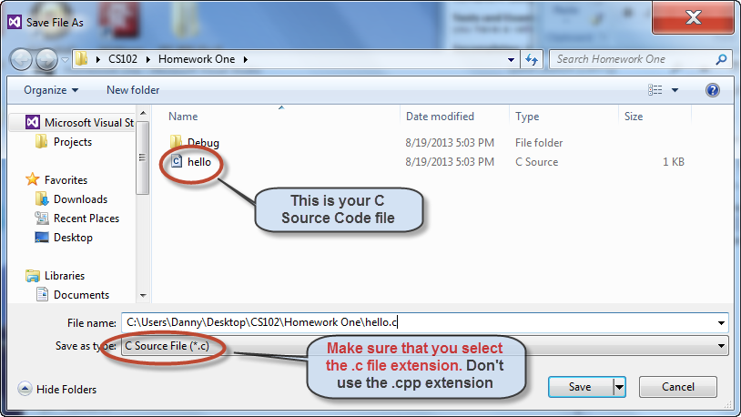
Dialog box with filename and C Source File type selected
Step 3.3 Click Save to save the file with the name shown in the “File Name” text box. IMPORTANT make sure you save as “C Source File (*.c)”
Step 4 Build and execute the program
Step 4.1 Build Build Solution or
Build Build Homework One
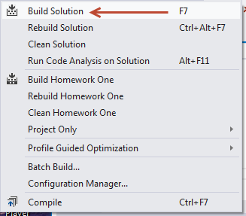
Not much will change on your screen. 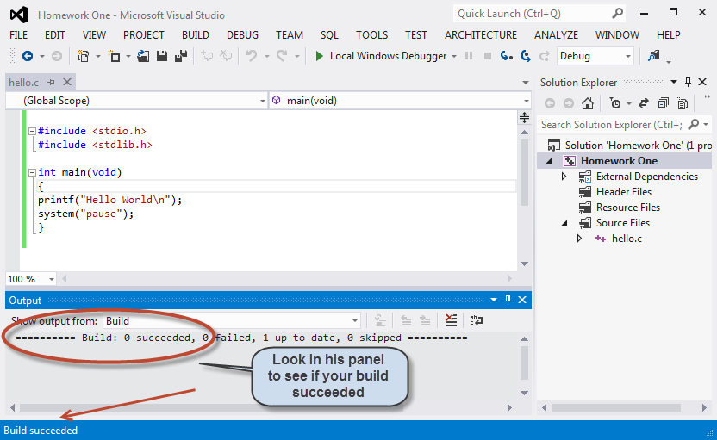
Screen appearance following build. Note “Build succeeded” message at bottom
Step 4.2 Run the program Debug Start Debugging, hit the F5 function key or
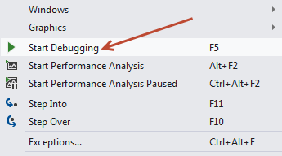
click on the green triangle on the tool bar.
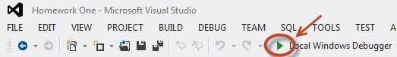

A new window will appear with the output from the program.
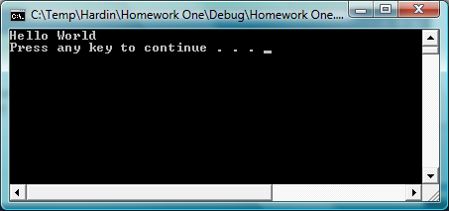
Output from program will appear in a separate window.

Congratulations you have completed your first program!

Part Two: How to Add an Existing C Program File to a
Microsoft Visual Studio 2012 Project

Step 1: You will need a Project File first. To create a new project follow the steps in Part One of this guide.
Step 1.1 If you already have an existing project open it.
File Open Project
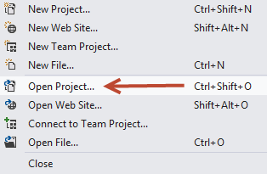
Step 1.2 Browse to a folder where you have saved your project files. Let’s use the Homework One project we completed above. Note that it is stored at C:/Users/Danny/Desktop /CS102/Homework One in this case. The name of the project file is Homework One.
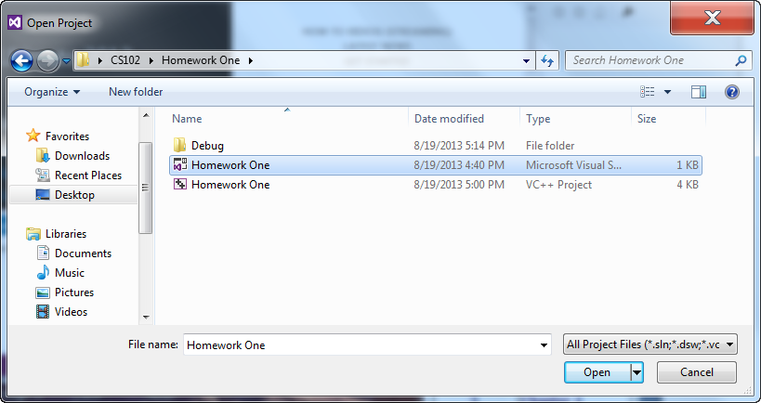Window showing files that were saved from the “Homework One” project of Part One.
Step 1.3 Click on the Homework One file to select it then click “Open”. The following window will appear which is exactly the Homework One project we did above with the hello.c C Program file included.
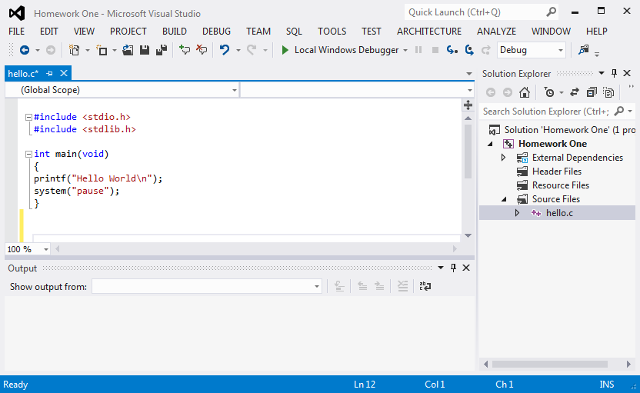
MVS 2012 with Homework One project and hello.c source code file

Step 2 Adding an existing C Program file to the current project.
Assume we have a C program file located in C:/Users/Danny/Desktop /CS102/
Step 2.1 Add an existing “Item” to the Project
Project Add Existing Item
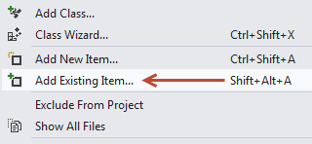

Step 2.1 B Alternate Method
Place the curser over the “Source Files” folder in the “Solution Explorer” and click the right mouse button (Right Click)
Then select Add Existing Item
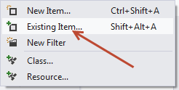
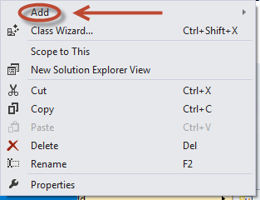

Altenate method to add an existing file. Right Click Add Existing Item
Step 2.2 Browse to location where C Source code file is located.
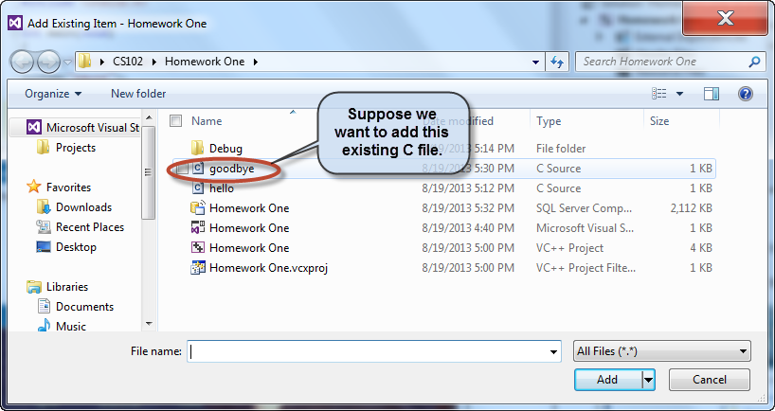
File window showing existing C Program file located at C:/Users/Danny/Desktop /CS102/

Step 2.3 Click on the C File and then Click Add
The file will be added to the “Source Files” folder as shown below.
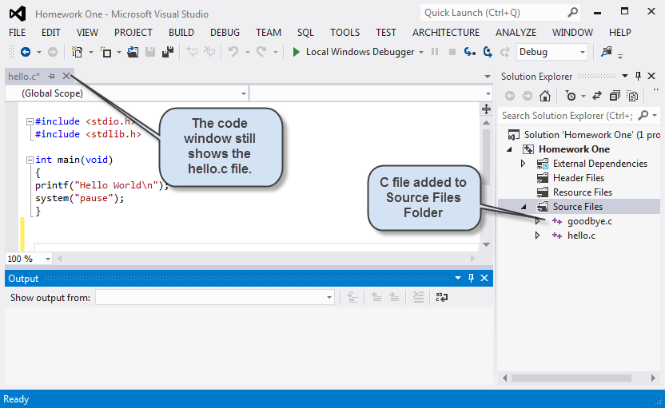
MVS 2012 showing existing file added to “Source Files” folder.
Step 2.4 To view the new file double click on its file name
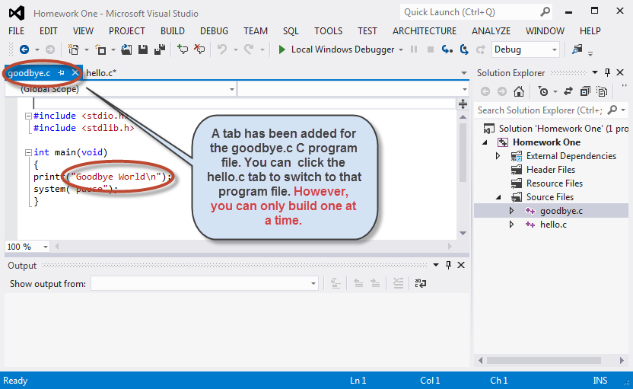
MVS 2012 with content of just added C Source file visible in a new tab.
Step 2.5 IMPORTANT Exclude the hello.c file from the “Source Files” folder in the Solution Explorer. (This must be done because each .c file has a main program and there can be only one “main” routine. Removing the hello.c file does not delete it.)
Step 2.5 Click on the hello.c file in the “Solution Explorer” to select it.
Then Project Exclude From Project
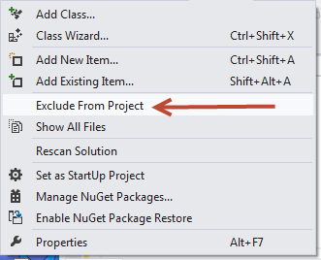
Step 2.5 B Alternate Method
Place the curser over the “hello.c” file name in the “Solution Explorer” and click the right mouse button (Right Click) The following pop up menu will appear:
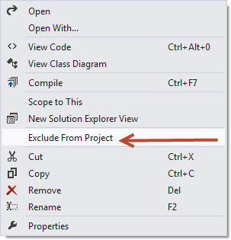
Popup menu resulting from right clicking on hello.c file name

Select Exclude From Project. Hello.c will be excluded from the project but will not be deleted.
Step 3 Build and Run the added program
Step 3.1 Build Build Homework One
Build Build Solution or
Build Build Homework One
Step 3.2 Run the program
Debug Start Debugging, press the F5 function key
Or click on the green triangle on the tool bar.

The output will appear in a separate window on screen.
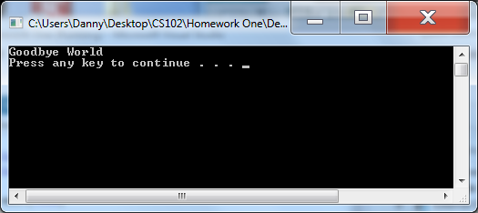
Window showing output from the C Program just added.

