Name: Your Name
Date: Homework Due Date
Assignment: First CS 102 Homework
Problem 1: Add two numbers
C Source Code
//
// NAME: Your Name
// DATE: Current Date
// PROGRAM: Add two numbers (Figure 2.5 Page 45 of textbook)
//

#include <stdio.h>

int main(void)
{
//
// Declare variables
//

int integer1;
int integer2;
int sum;

// Prompt user to enter first number

printf("Enter an integer number\n");
scanf("%d", &integer1);

// Prompt user to enter second number

printf("Enter another integer number\n");
scanf("%d", &integer2);

// Calculate sum

sum = integer1 + integer2;

// Output the result to the console

printf("The sum is %d\n\n", sum);

system("pause");

}

Output of program (Include enough screen captures to prove that the program executes and produces the correct output.)
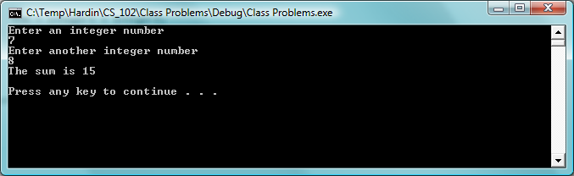
Output of program showing the correct addition of two input integer values
Problem 2: Make an Arrow design and a cat.
C Source Code
//
// PROGRAM: This program creates a simple ASCII cat design using special characters.
// It illustrates the use of the backslash character
//

#include <stdio.h>
#include <stdlib.h>

int main(void)
{

printf("\n\n");
printf("ARROW\n\n");

printf("\\\\\\\n");
printf("--->\n");
printf("///\n");

printf("\n\n");
printf("CAT\n\n");
printf("\n\n");

printf(" / )\n");
printf(" / / \n");
printf(" / / /\\ \n");
printf(" / / .-```-. / ^`-. \n");
printf(" \\ \\ / \_\/ (|) `o \n");
printf(" \\ \\ / .-. \\\\ _ ,--' \n");
printf(" \\ \\/ / ) \\( `^^^ \n");
printf(" \\ \\/ ( ) \n");
printf(" \\ ) ) / \n");
printf(" jgs ) /__ | (__ \n");
printf(" (___))) (__)))\n");

printf("\n\n");
system("pause");
}
Output of Program

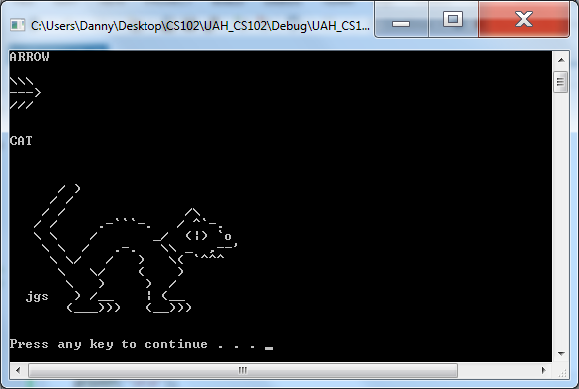

Continue with other programs giving C Source code and output for each.

