Getting Started with Microsoft Visual Studio 2012

- Start MVS 2012 from the Start button at bottom left of screen.
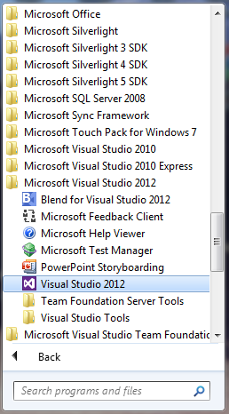

- This screen will appear. (If you are using MVS Express there may be some differences.
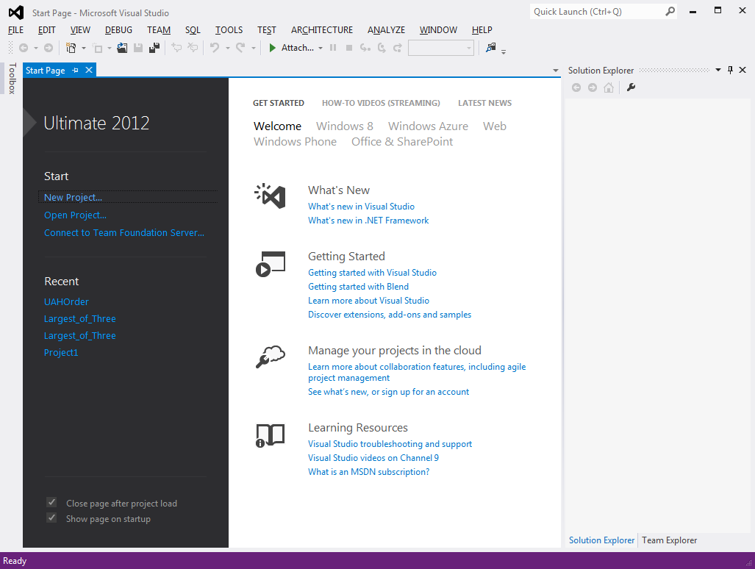

- To make a new project select New Project from the File menu. This (or similar) dialog box will appear.

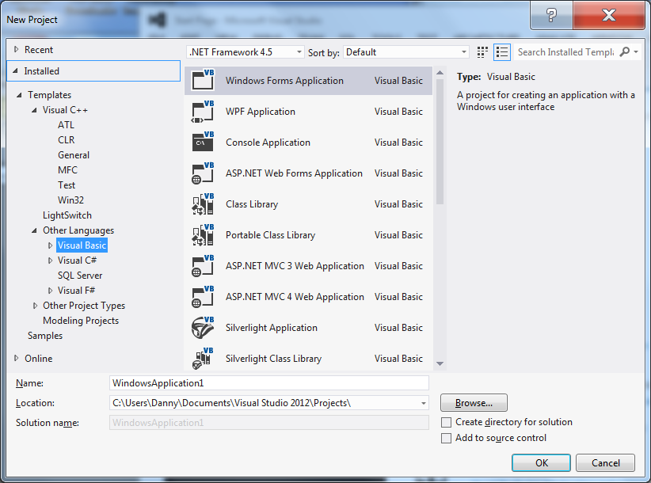

- From the left side panel click “Visual Basic” from the “Other Languages” tab if it is not already selected.

- In the central panel be sure that Windows Form Application” is highlighted.

- At the bottom enter a name for your project in the Name textbox. Choose a descriptive name like “Homework Problem 12”. IMPORTANT: Do not use special characters like / : ! $ , etc. Only use letters numbers and spaces.

- Use the Browse button to set the Location where your files will be stored. In this course I recommend that you create a folder on your desktop called CS100 and put all you project folders in there.

- Make sure that the checkbox next to “Create directory for solution” is NOT CHECKED.

- The dialog box should now look like this:

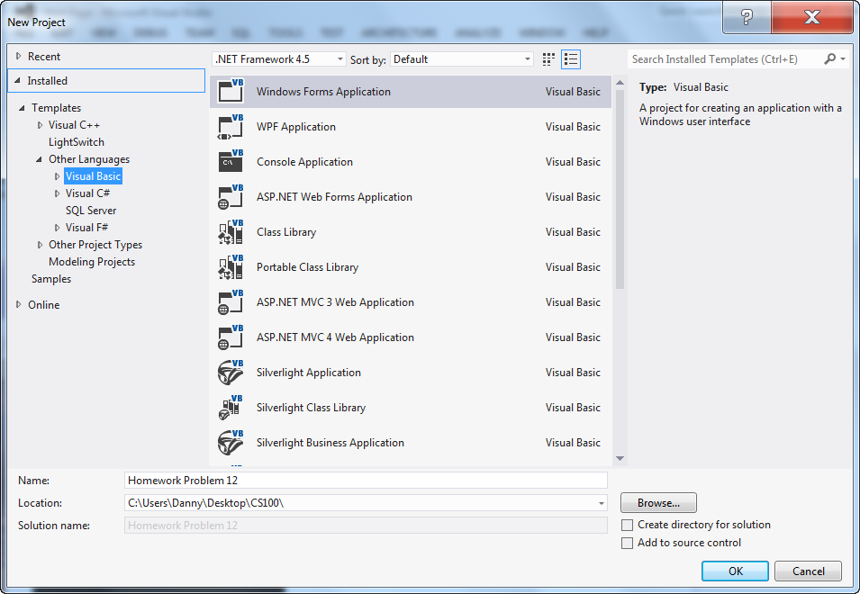

- Click OK. The MVS Integrated Development Environment will now open. It will look something like this. Some of these panels may not appear on your screen. (You can open them from the View menu.)

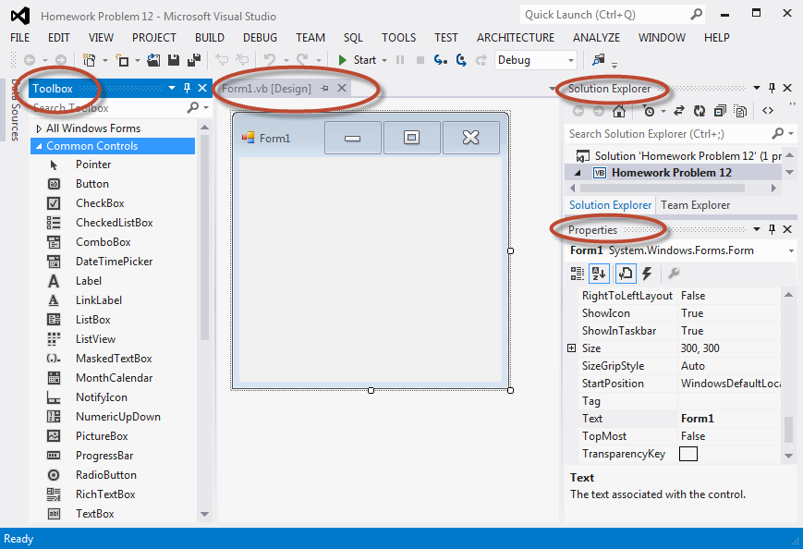

- You are now ready to design the interface (form) for your project by adding controls from the Toolbox and Visual Basic code to make the form function. You will see how to do this in class. For now assume that you will only have this blank form.
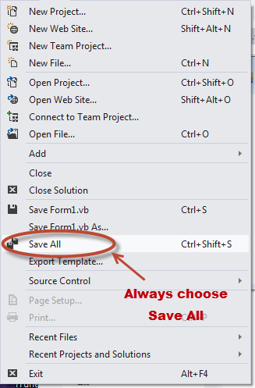
- Saving your work: When you have finished your project select “Save All” from the File menu or click the multi-disk icon on the tool bar. This will save all of your files. It will not prompt you for verification. Do not choose the “Save As” option as it will not save everything!

- Check your folder to make sure the files are all there. Double click the “CS100 Folder” on the desktop and navigate to your project folder – in this example it will be named “Homework Problem 12”. Double click the folder to view all the files created by Visual Studio for your project. It will look something like this:

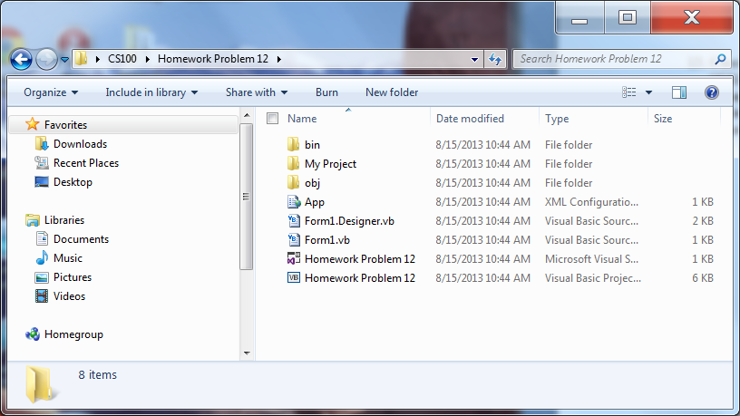

Note the Folder Name “Homework Problem 12” and the contents of the folder. You should always these 8 items. (If you are using the Express edition you may have another file.)

- VERY IMPORTANT. To turn in your project files for grading copy the entire folder “Homework Problem 12” to your thumb drive to save for yourself or to turn in for homework.

