Jason Jones
CS 100 Example Homework
August 24, 2013
Problem 1: Add Two Numbers

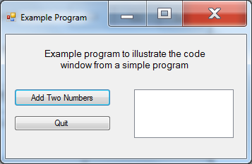

Code for Problem One

'
' Example Program
' Jason Jones
'
' This programs adds two numbers
'
' Due Date:

Public Class frmExample

Private Sub btnAdd_Click(sender As Object, e As EventArgs) Handles btnAdd.Click
Dim sum As Integer

'
' Add the numbers 134 and 68
' Write the answer to the list box
'

sum = 134 + 68

lstOut.Items.Add("The sum is: " & sum)

End Sub

Private Sub btnQuit_Click(sender As Object, e As EventArgs) Handles btnQuit.Click
End
End Sub

End Class

Problem 2: Calculate Area of Circle

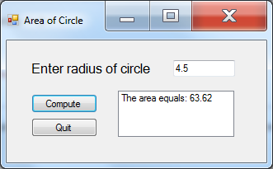

Code for Problem Two
'
' Jason Jones
'
' Problem 2
' This program computes the area of a circle given the radius
'
' Due Date

Public Class frmArea

Private Sub btnCompute_Click(sender As Object, e As EventArgs) Handles btnCompute.Click
Dim radius As Double
Dim Area As Double

' Import the value for radius

radius = CDbl(txtRadius.Text)

' Compute Area

Area = 3.14159 * radius ^ 2

' Output the result

lstOut.Items.Add("The area equals: " & FormatNumber(Area, 2))

End Sub

Private Sub btnQuit_Click(sender As Object, e As EventArgs) Handles btnQuit.Click
End
End Sub
End Class

And so on for additional problems.

