Instructions for Submitting CS-100 Homework Assignments
For all homework assignments (except the first one) you will turn in the following items:
- A screen capture of the form in action (running or active) for each homework problem. Copy and paste the screen capture into a Word Document as described below.
- A printed listing of the Visual Basic code used to make the form operate. (not required for the first assignment since there is no code involved) You may copy and paste the code from the Visual Basic code window into the Word document along with the screen captures OR you may print the code directly from the Visual Basic code window with the Print command under the File menu.
- A flash drive with all the project files for each assigned program. Remember to copy the entire project folder from the computer to the flash drive.
- Put all of the above items into a folder with a secure closure. (A manila envelope is OK.)
Specific Details and Instructions
1. Open a Microsoft Word document. Enter your name, date and a description of the homework assignment at upper left. Save the Word document to a place of your choice. (Saving it in the same location as you project files would be a good choice.)
2. Obtain a screen capture of the form by doing the following:
A. When you have completed your program start it up by pressing the little green triangle (Start) on the tool bar of Visual Basic 2012 or hit the F5 function key.
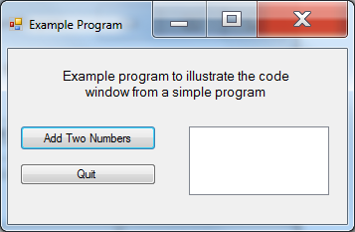
B. Make sure the form is selected by placing the curser over it and clicking.
C. Hold down the Alt Key and press the “Prt Scrn” Key located above the numeric keypad at upper right. This copies the form image to the clipboard. Here is an example - right.
D. Go to the Word document and select paste from the Edit menu or just use Ctrl + V to paste the screen capture into the Word document.

3. Get a printout of the Visual Basic Code. (Not required for assignment one)
A. Click the “Form1.vb” Tab at the top of the central work area. (The other tab shows the design view.) It looks something like this. (I closed the other panels – Toolbox, Properties and Solution Explorer to get this uncluttered view.)
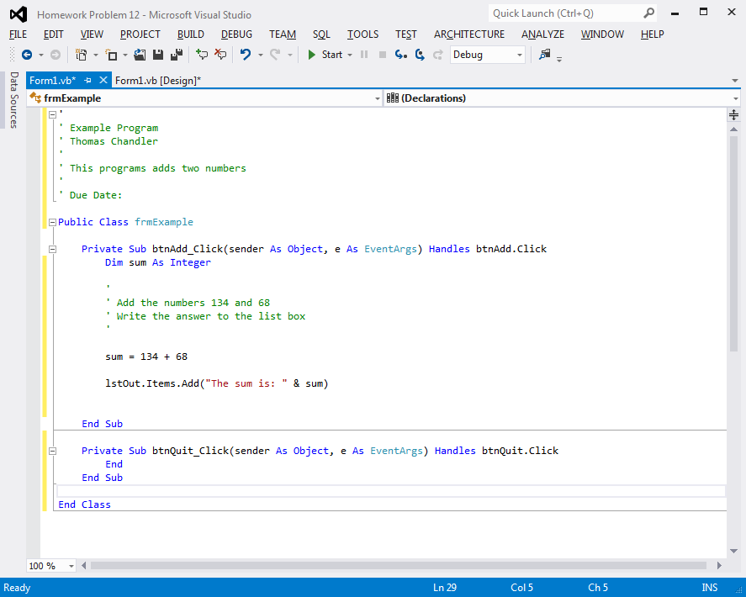
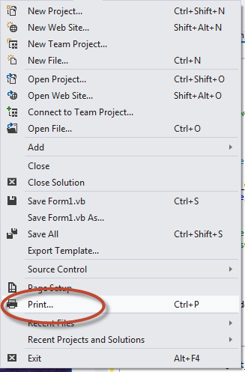
B. The simplest way to get a printout of this code is to print it directly with the Print option under the File menu. (Be sure that you select one of the printers in the classroom if you are doing this from Tech Hall N327.)
C. The other option is to copy the code from the code window by selecting all the code (Place curser at top left, hold down left mouse button and drag to bottom) then select Copy from the Edit menu. Now go to your Word document and paste.

D. Here is an example of copying and pasting. Word will try to spell check. Don’t worry about that.

'
' Example Program
' Thomas Chandler
'
' This programs adds two numbers
'
' Due Date:

Public Class frmExample

Private Sub btnAdd_Click(sender As Object, e As EventArgs) Handles btnAdd.Click
Dim sum As Integer

'
' Add the numbers 134 and 68
' Write the answer to the list box
'

sum = 134 + 68

lstOut.Items.Add("The sum is: " & sum)

End Sub

Private Sub btnQuit_Click(sender As Object, e As EventArgs) Handles btnQuit.Click
End
End Sub

End Class

4. Repeat steps 2 and 3 for every problem in the assignment.
5. When finished print out your Word document.
6. Now for the files. Insert your flash drive and create a new folder named for the assignment. (e.g. “CS100 Homework Assignment One”) Now locate your project files on the computer and copy the entire folder for each project onto your flash drive.
7. Place the print outs and flash drive in a secure folder with your name on the outside.
8. Turn in at the BEGINNING of the class on the due date.

For Homework Assignment one you will be graded on the following:
A. One point for completion of each project with all controls properly named. (7 points possible) NOTE: These projects should be completed using only the Button (btn), Label (lbl), ListBox (lst) and Textbox (txt) controls introduced in section 2.1.
B. One point for saving all necessary files to your media
C. One point for having a folder
D. One point for having your name on the folder, printout, and media.
All other assignments will be graded on a ten-point basis
General Information
A. Do not put extraneous files on your homework media. Keep in-class work and personal files separate. It is OK to keep old homework folders on your media. Just be sure that they are clearly named.
B. The Visual Basic text book and in-class lectures specify proper naming conventions for all controls, and proper techniques for structuring your VB programs. If these are not followed then your problem will be considered WRONG even though it might produce the desired result. Follow the rules.
C. Make sure your name is on all items you turn in: Media, Printout, and Folder.
D. Submit all materials for each assignment in a folder that will keep everything together.

